Value conversion to Boolean :

When you convert your expression given in varible into Boolean it is false in the following cases :

When you convert your expression given in varible into Boolean it is true in the following cases :

var name=""; // value is empty anser will be false of else block

var name2;   // value is undefined answer will be false of else block

var name3="a" // value is defined answer will be true of if block executed.

if(name2){  // if representes true value excution in its block body

    alert(name3);

}

else{ // else represents false value execution in its block body

    alert(name3);

}

In and operator which value bcomes false the result will be false no further check.

And it all values in and operator is true then it return last comapared value in output.

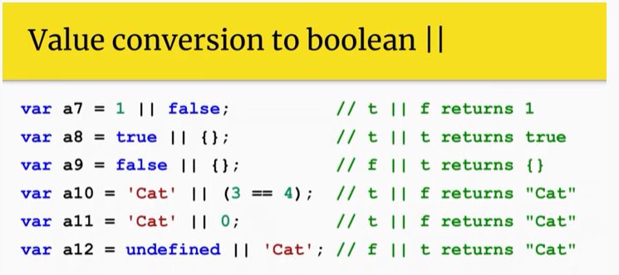

In or operator which value bcomes true the result will be true no further checks if more values to be compared available.

And if all values in or operator is false then it return last compared value in output.